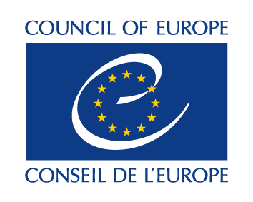

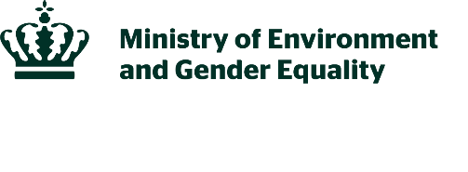
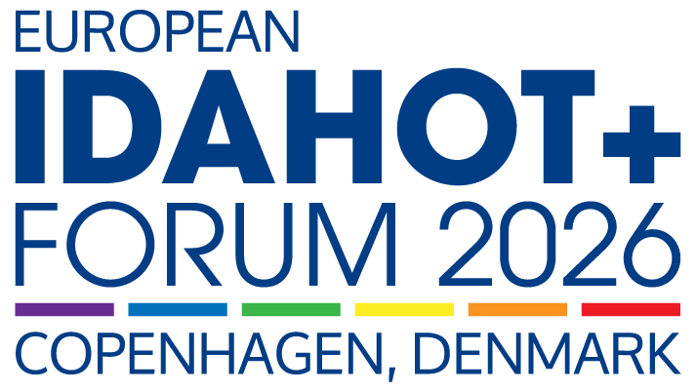

19 May 2026

PUSHING FOR PROGRESS: Addressing Challenges and Shaping the Future of LGBTI Equality in Europe

09.00 OPENING SEGMENT
The Forum will begin with high-level speeches from ministers and international representatives including from the Nordic Council of Ministers and the Council of Europe. They will set the scene and reflect on the state of LGBTI equality across the region.

- Welcome and opening speeches
- Danish Minister of Gender Equality
- Bjørn Berge, Deputy Secretary General, Council of Europe

- Key note: Gergely Karácsony, Mayor of Budapest, Hungary

- Testimony: Enes Hocaoĝullari, ÜniKuir Association, Türkiye

- Panel: Pushing for Progress - Conversation with Nordic Ministers for Equality.
- Chair: Karen Ellemann, Secretary General, Nordic Council of Ministers
- Hanna Katrín Friðriksson, Minister of Industries, Iceland
- Trude Storheim, State Secretary of Culture and Equality, Norway
- Katarina Lundahl, State Secretary for Gender Equality, Sweden
- Laura Rissanen, State-secretary for Gender equality, Finland

10.45 PLENARY I – ADVANCING LGBTI STRATEGY IN EUROPE: CHALLENGES AND OBSTACLES
This session will explore the current state of LGBTI rights in Europe, highlighting challenges and obstacles. Experts and international organisations will share research, policy insights, and advocacy experiences.

- ILGA Europe 2026 Rainbow Map: Katrin Hugendubel, Advocacy Director, ILGA Europe

- Key note: TBC

- Testimony: Chay Brown, TransActual, United Kingdom

- Panel: Anti-democratic Backlash and Core Challenges for LGBTI Communities
- Moderator: Moussa Mchangama
- Hallvard Gorseth, Director of Equal Rights and Dignity, Council of Europe
- Cecilia Strand, Senior Lecturer/Associate Professor, Uppsala University
- Jelle Postma, Director, Justice for Prosperity
- Isa Nico Borrelli, Chair, Transgender Europe

12.10 BREAKOUT SESSIONS
Participants are asked to pre-register for a breakout session during registration for the IDAHOT+ Forum.

- Living conditions for LGBTI people in rural areas
Studies show that LGBTI people´s living conditions vary depending on where they live. In rural and sparsely populated areas, there are specific challenges linked to geographical, social, and cultural conditions. In this session, you will have the opportunity to hear the latest knowledge and experiences.

- Moderator: Andreas Nielsen, Deputy Head of Department, Nordic Council of Ministers
- Keynote: Kajsa Widegren, Analyst and Researcher, Swedish Secretariat for Gender Research
- Isabel Flemming, Director of the Rainbow Alliance in Swedish-speaking Finland
- LGBT+ Foröyar or Sipineq+ (TBC)
- Rafael Benitez, Director of Social Rights, Health, and Environment, Council of Europe

- Challenges and opportunities for LGBTI persons in a digital age
The rapid advancement of digital technologies presents unique challenges and opportunities for the protection of the rights of LGBTI people online and offline. From barriers to participating fully and equally online, this panel will unpack several intersecting issues that deeply influence how LGBTI people experience the digital sphere.

- Moderator: Deekshitha Ganesan, Manager – Policy and Advocacy, TGEU
- Tamás Dombos, Executive Board Member and Project Coordinator, Háttér Society
- Richard Köhler, Expert Advisor and Senior Policy Officer, TGEU
- Luna Liboni, Research and Policy Manager, TENI Ireland
- Jelena Vasiljevic, Executive Director, Rainbow Ignite

- Dynamics of violence, honour, and control within families
This breakout session focuses on the experiences of LGBTI persons affected by honour-related violence and social control, with particular attention to minority ethnic communities. This can have serious consequences, such as family rejection, restricted freedom, violence and risks to personal safety, while access to relevant support may be limited.

- Moderator: Ane Villumsen, Chief Advisor, Danish Ministry of Gender Equality
- Hanna Cinthio, Scholar of Middle Eastern Studies and PhD in social work
- Susanne Knoefel, Head Of Unit, EU Commission
- Illaria Todde, Advocacy Director, EL*C - Eurocentralasian Lesbian* Community
- Kristína Buchelová, European Forum of LGBTI+ Christian Groups
- Anita Johnson, President, RED+
- Aslan, RED+

- A pathway to advancing LGBTI-inclusive education
LGBTI students across Europe continue to experience bullying, exclusion and insecurity in educational settings, while schools and education authorities are increasingly confronted with anti-rights attacks that seek to roll back work on equality, safety and inclusion.

- Giulia Bianchini, Senior Project Officer, Council of Europe SOGIESC Unit
- Rú Ávila Rodríguez, Deputy Executive Director, IGLYO
- Aaron Giardina, Assistant Director, Human Rights Directorate, Malta
- Sylvain Séguy, Associate Programme Specialist, UNESCO
- Kerttu Tarjamo, Secretary General, Seta LGBTIQ Rights, Finland
- Jo Matos, Director General, rede ex aequo
- Robert Attard, Community Officer, MGRM

13.10 LUNCH BREAK

14.10 PLENARY II – PUSHING FOR PROGRESS
This session will focus on strategies and initiatives driving LGBTI equality forward across Europe. Speakers will highlight successful advocacy efforts, policy developments, and collaborative approaches that have made a tangible impact, offering inspiration and practical ideas for advancing rights and inclusion.

- Key note: Sophie Koch, German Commissioner for the Acceptance of Sexual and Gender Diversity,
- Testimony: Sipineq+ (TBC)

- Panel: Pushing for Progress – Strategic Ways Forward
- Moderator: Moussa Mchangama
- Aurora Ailincai, Head of Anti-Discrimination and Inclusion Department, Council of Europe
- Majbrit Berlau, General Director, Danish IPPF
- Ilaria Todde, Advocacy Director, EL*C - Eurocentralasian Lesbian* Community
- Andreas Nielsen, Deputy Head of Department, Gender Equality and LGBTI, Nordic Council of Ministers

15.25 BREAKOUT SESSIONS
Participants will be asked to pre-register for a breakout session during registration for the IDAHOT+ Forum.

- Inclusion in the labour market for LGBTI persons
Working life conditions for many in the LGBTI group are worse than for the majority population. LGBTI people are more likely to experience harassment and discrimination in working life, both at work and in recruitment processes. This session will provide a comprehensive picture of the current situation, sharing insights from research, policy and practice.

- Moderator: Andreas Nielsen, Deputy Head of Department, Nordic Council of Ministers
- Key note: Susanna Young Håkansson, Analyst, Swedish Secretariat for Gender Research
- Kajsa Widegren, Analyst and Researcher, Swedish Secretariat for Gender Research
- Alejandro Betancour, Vice-Chair, Business Pride Europe
- Sara Lynge Skovhede, DEI-Lead, Novonesis

- Recognizing the life of intersex persons
This break-out session will create the possibility to explore existing good practice and potential measures to reduce existing gaps within national protection of intersex persons across the Council of Europe region through a cross-country exchange between intersex NGOs.

- Moderator: Dan Christian Ghattas (he/they), Executive Director, OII Europe
- Yanna Parnin, Head of the SOGIESC Unit, Council of Europe
- Inge Toft Thapprakhon, Spokesperson, Intersex Denmark
- Kristian Randelović, Intersex Activist, Human Rights Defender and Co-Founder, XY Spectrum
- Belgin Günay (they/them) - İnter Dayanışma
- Andra Minoa (she/her) - OII Germany - IVIM

- Speech workshop: How to build arguments in times of change
This workshop will inspire the participants to engage in public speaking, whether it be on stage, in meetings, or at community events. We guide the participants through the different phases of speechwriting: understanding your audience, generating ideas, writing the speech, and delivering it to an audience.

- Martin Fehr Therkildsen, RØST

16.45 CLOSING SEGMENT
The Forum will close with remarks from key speakers, summarising the main outcomes of the day and reinforcing commitments to advancing LGBTI equality. This session will include the handover of the hosting role to the United Kingdom, calling for continued collaboration, policy innovation, and advocacy to ensure LGBTI rights and equality across Europe.

- Testimonies: Eka Tsereteli, Women’s Initiatives Supporting Group, Georgia

- Closing remarks: Danish Minister for Gender Equality

- Closing remarks: Olivia Bailey, Minister for Early Education and Minister for Equalities, United Kingdom

17.20 OFFICIAL CLOSING OF THE 13TH EUROPEAN IDAHOT+ Forum

17.30-23.00: SOCIAL PROGRAMME – RAINBOATS TOUR AND CASUAL DINNER
Participants are invited to a Rainboat tour of Copenhagen with storytelling of the city’s LGBTI history. The boat tour will drop off participants at restaurant Pakhus Bryggen for a casual dinner.

