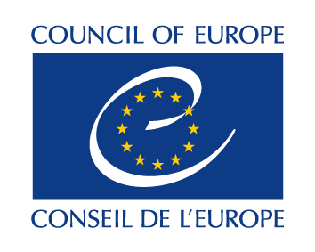

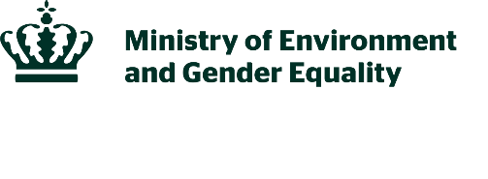
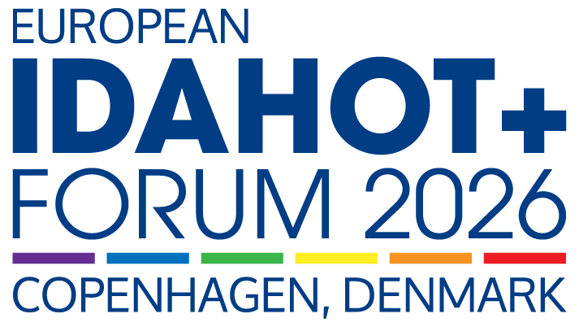

BREAKOUT SESSIONS

1. Living conditions for LGBTI people in rural areas
Studies show that LGBTI people´s living conditions vary depending on where they live. In rural and sparsely populated areas, there are specific challenges linked to geographical, social, and cultural conditions, including access to support services, healthcare, and social networks. In this session, you will have the opportunity to hear the latest Nordic knowledge in this field and meet organisations sharing knowledge and experiences from their work to strengthening LGBTI rights in rural areas.

Agenda
- Keynote: An overview of the latest research and insights from a Nordic perspective. incl. questions
- Report: NIKK (Nordic Information on Gender) presents their report incl. questions
- Presentation and discussion

Participants
- Moderator: Andreas Nielsen, Senior advisor, Nordic Council of Ministers
- Keynote: Kajsa Widegren, Analyst and Researcher, Swedish Secretariat for Gender Research
- Isabel Flemming, Director of the Rainbow Alliance in Swedish-speaking Finland
- Sipineq+ (TBC)
- Rafael Benitez, Directorate of Social Rights, Health, and Environment, Council of Europe

2. Challenges and opportunities for LGBTI persons in a digital age
The rapid advancement of digital technologies and the growing moves for digitalisation of public infrastructure present unique challenges and opportunities for the protection of the rights of LGBTI people online and offline. From barriers to participating fully and equally online, the proliferation of anti-LGBTI content through algorithmic amplification and the use of facial recognition to quell peaceful assemblies to efforts to strengthen content moderation rules and the promise offered by data protection laws to secure legal recognition, this breakout session will unpack several intersecting issues that influence how LGBTI people experience the digital sphere.

Agenda
- Introduction
- Moderated discussion
- Q&A

Participants
- Moderator: Deekshitha Ganesan, TGEU
- Tamás Dombos, Hatter Society
- Richard Köhler, TGEU
- Luna Liboni, TENI Ireland
- Jelena Vasiljevic, Rainbow Ignite

3. Dynamics of violence, honour, and control within families
This breakout session will focus on the experiences of LGBTI persons affected by honour-related violence and social control, with particular attention to minority ethnic communities. While honour-related violence has gained increasing attention across Europe, the specific challenges faced by LGBTI persons in these contexts remain underexplored. Minority ethnic LGBTI persons may experience overlapping forms of pressure, including control, exclusion, and expectations of conformity linked to religion, honour, and reputation. This can have serious consequences, such as family rejection, restricted freedom, violence and risks to personal safety, while access to relevant support may be limited.

Agenda
- Key note: Research-based presentation on vulnerabilities of minority ethnic LGBTI persons in contexts of honour-related violence, including barriers to seeking help
- Practice-based perspectives: Presentations from the Danish specialised crisis shelter RED+ focusing on frontline experiences, adaptations to existing support systems, and gaps in current service provision.
- Panel discussion and Q&A: Panel will explore how we develop initiatives that are both honour-sensitive and LGBTI inclusive, how to prevent minority ethnic LGBTI individuals from falling between existing services, and what the most urgent steps are to strengthen protection of this group.

Participants
- Moderator: Ane Villumsen, Chief advisor, Danish ministry of Gender Equality
- Hanna Cinthio, Scholar of Middle Eastern Studies and PhD in social work
- Susanne Knoefel, Head Of Unit, EU Commission
- Illaria Todde, Advocacy Director, EL*C - Eurocentralasian Lesbian* Community
- Kristína Buchelová - European Forum of LGBTI+ Christian Groups
- Anita Johnson, President, RED+
- Aslan, RED+

4. A pathway to advancing LGBTI-inclusive education
This breakout session will present a new three-part toolkit developed by the Council of Europe SOGIESC Unit and IGLYO to support safer, more inclusive and more democratic education systems across Europe. The toolkit brings together policy guidance on addressing SOGIESC-based bullying in schools, practical guidance on countering anti-rights discourse in education, and a framework for competence-based teacher training for educators. The breakout session is designed not only to introduce these tools, but also to open a practical discussion on how they can help address the current challenges facing education systems in different national and local contexts.

Agenda
- Key note: Anti-rights discourse on education, and presentation of the three tools
- Intergovernmental perspective: Countering anti-rights backlash in education, preventing and responding to gender-based and SOGIESC-based violence, and evidence on inclusive comprehensive sexuality education
- Interactive discussion: In small groups on the practical uses, gaps and implementation needs of the tools
- Implementation: In a national context and next steps for piloting

Participants

- Giulia Bianchini, Senior Project Officer, Council of Europe SOGIESC Unit
- Rú Ávila Rodríguez, Deputy Executive Director, IGLYO
- Aaron Giardina, Assistant Director, Human Rights Directorate, Malta
- Sylvain Séguy, Associate Programme Specialist, UNESCO
- Kerttu Tarjamo, Secretary General, Seta LGBTIQ Rights, Finland
- Jo Matos, Director General, rede ex aequo
- Robert Attard, Community Officer, MGRM

5. Inclusion in the labour market for LGBTI persons
Working life conditions for many in the LGBTI group are worse than for the majority population. LGBTI people are more likely to experience harassment and discrimination in working life, both at work and in recruitment processes. Particularly vulnerable groups include young LGBTI people, transgender people and LGBTI people with ethnic minority backgrounds. This session will provide a comprehensive picture of the current situation, with participants sharing insights from research, policy and practice.

Agenda
- Key note: An overview of research and insights from a Nordic perspective incl. question
- Panel and Q&A: Moderated discussion between stakeholders incl. questions

Participants
- Moderator: Andreas Nielsen, Senior Advisor, Nordic Council of Ministers
- Key note: Susanna Young Håkansson, Analyst, Swedish Secretariat for Gender Research
- Kajsa Widegren, Analyst and Researcher, Swedish Secretariat for Gender Research
- Alejandro Betancour, Vice-Chair, Business Pride Europe
- Sara Lynge Skovhede, DEI-Lead at Novonesis

6. Recognizing the life of intersex persons
This breakout session will give an overview of the Council of Europe recommendation “Recommendation CM/Rec(2025)7 of the Committee of Ministers to member States on equal rights for intersex persons” and its main aspects followed by a panel which will focus on different articles of the recommendation. Panellist will be talking in rounds, highlighting aspects of these articles which are particularly relevant for implementation in their national context, with a focus on good practice. This part will include practical examples on how challenges were navigated and solutions were found giving inspiration for implementation measures in similar contexts on national but also sub-national and municipal level with the objective to create an inspirational conversation among the panellist and with the audience in the subsequent Q&A.

Agenda
- Key note: Presentation of the recommendation
- Panel discussion: With intersex panellist and key note speaker
- Q&A: The audience is invited to engage with the panel

Participants
- Moderator: Dan Christian Ghattas (he/they), Executive Director, OII Europe
- Yanna Parnin, Head of the SOGIESC Unit, Council of Europe
- Inge Toft Thapprakhon, Spokesperson, Intersex Denmark
- Kristian Randelović, Intersex Activist, Human Rights Defender, and Co-Founder, XY Spectrum
- Belgin Günay (they/them) - İnter Dayanışma
- Andra Minoa (she/her) - OII Germany - IVIM

7. Speech workshop: How to build arguments in times of change
At this workshop we will inspire the participants to engage in public speaking, whether it be on stage, in meetings, or at community events. We guide the participants through the different phases of speechwriting: understanding your audience, generating ideas, writing the speech, and delivering it to an audience. At Røst we focus on building people up and acknowledging how everyone’s voice matters. We have a special focus on body language, voice skills, and how to handle the feeling of being nervous.

Agenda
- Introduction and key note
  - Understanding your audience
  - Generating ideas and finding arguments
  - Giving your speech a structure and choosing your words wisely
  - How to handle your feelings of being nervous
  - Delivering your speech
- Q&A: The audience is invited to engage with Røst.

Participants

- Kristian Faurby Nørgaard, RØST
- Martin Fehr Therkildsen, RØST

